ManagerWeb

Release 1.0/1.1 Delivery Strategy

Date: January 14, 2016  
Version: 2

# WebManager Release 1.0/1.1 Delivery Strategy

## Summary

This document serves as a high-level guide to the release timelines associated with the new ManagerWeb application as well as some details around the other related deliverables necessary to ensure successful execution.

## Release features

**Release 1.0**

* Document Library
  + bona fide content management
  + abandonment of rigid, pre-determined information hierarchy
* Communications
  + selected, regular communications transitioned from traditional email distribution
  + persistent, accessible archive
* Packages (Featured Content)
* Calendar
* Alerts

**Release 1.1**

* Feedback adjustments
* Ongoing aesthetic improvements

**Release 2.0 and beyond**

* ** Final Feature Set TBD **
* Proposed
  + individual logins for all users
  + analytics
  + analytics reporting

## Timelines

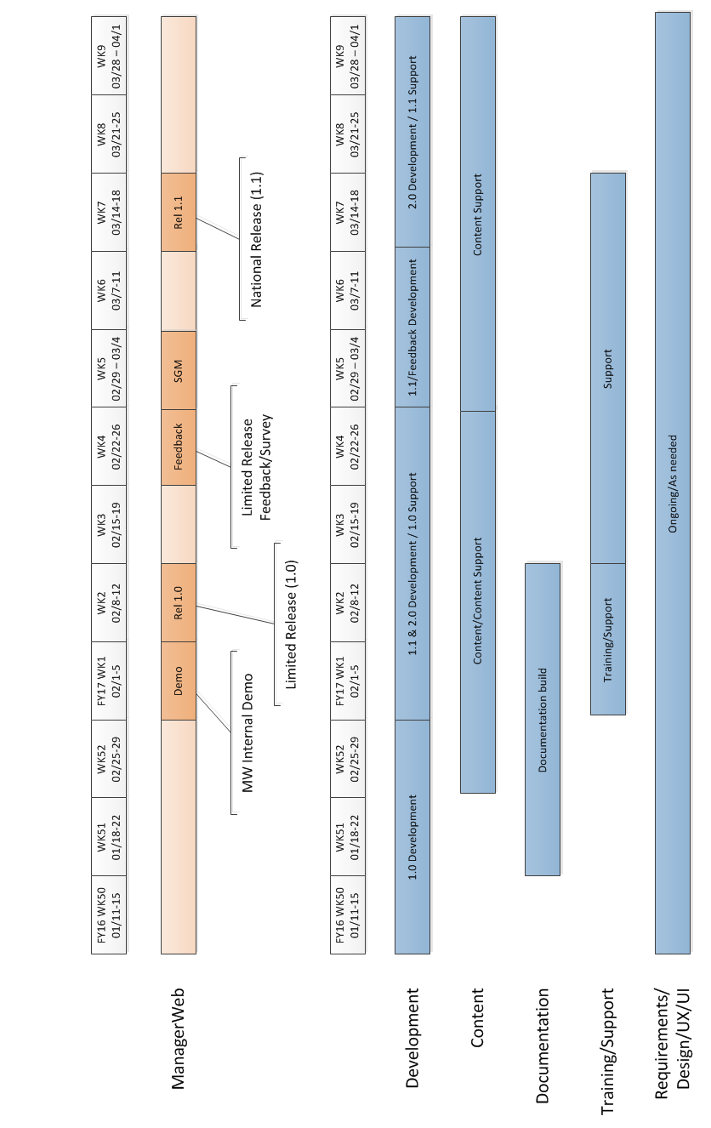

## Development

**Deliverables**

* Release 1.0: Limited release
* Release 1.1: First National release
* Release 2.0+: Subsequent National releases

## Content

**Deliverables**

* Direct content population during limited release
* Information Architecture (IA) and Taxonomy
* Process outline

## Documentation

**Deliverables**

* Application documentation
* Content delivery/management documentation

## Training/Support

**Deliverables**

* ManagerWeb feature overview/training
* Content management best practices, workflow

**Format**

* Leverage prepared documentation
* Workshops
* One-on-one training

## Requirements Gathering/Design/UX/UI/Project Management

**Deliverables**

* Wireframes/Mockups
* User stories
* Project Charter
* Formal/Informal Requirements
* Focus groups
* Feedback/Survey
* General resource coordination

**Internal Operations Support Transition/Roles**

The roles outlined below are not necessarily full-time jobs; they can also be built into existing positions.

|  |  |  |
| --- | --- | --- |
| **Role/Function** | **Responsibilities** | **Designated Resource(s)** |
| Content Lead | * Taxonomy design/management   + tagging * Governance * Curation * High-level coordination/scheduling * Document Upload * Communication upload/posting |  |
| Content Manager | * Document Upload * Content Coordination (Ensuring expected documents are received and posted according to schedule) |  |